Parallelepipeds

Definition
# Source: AI Source: Provided by: [Data Path: Persons Table -> ID Column: 1, Name_En Column: Motasem Essam] -> From: [ChatGPT] on [7/25/2026]
A parallelepiped is a three-dimensional polyhedron whose six faces are parallelograms. It has three pairs of opposite faces, and each pair consists of congruent and parallel parallelograms.
A parallelepiped is formed by extending a parallelogram in a direction that is not necessarily perpendicular to its plane.
It has:
- 6 faces.
- 12 edges.
- 8 vertices.
- 3 pairs of opposite, parallel faces.

Simple Definition
# Source: AI Source: Provided by: [Data Path: Persons Table -> ID Column: 1, Name_En Column: Motasem Essam] -> From: [ChatGPT] on [7/25/2026]
A parallelepiped is a solid with six parallelogram-shaped faces, where opposite faces are parallel and equal in shape and size.
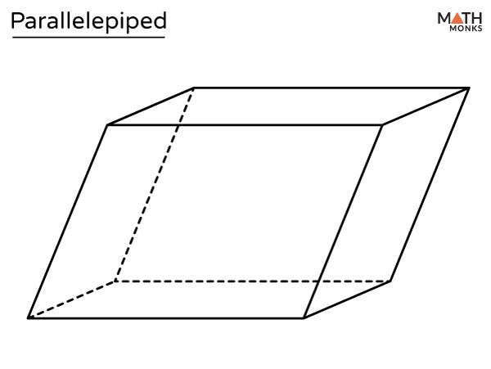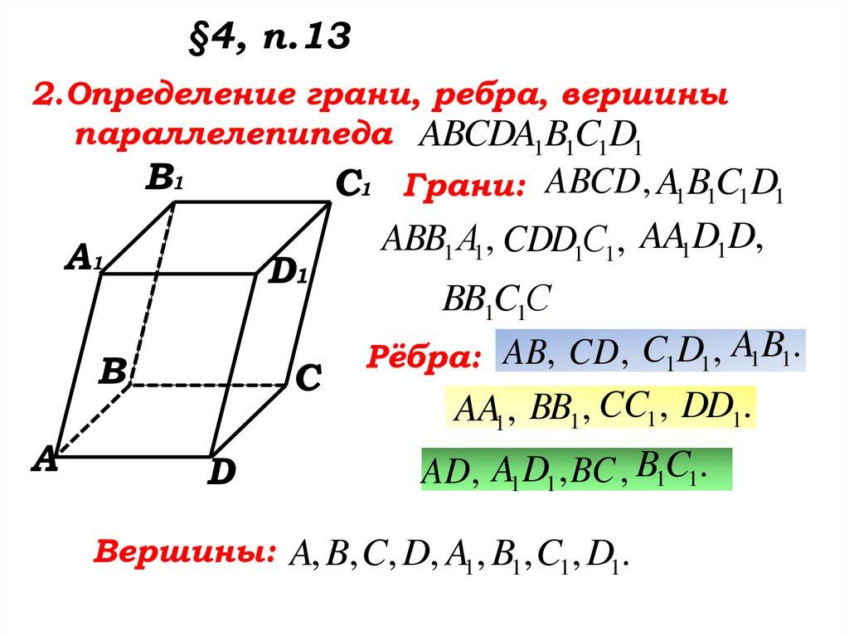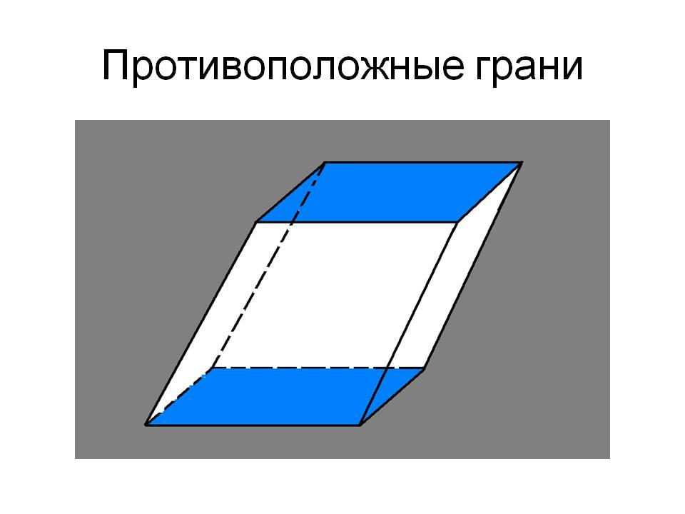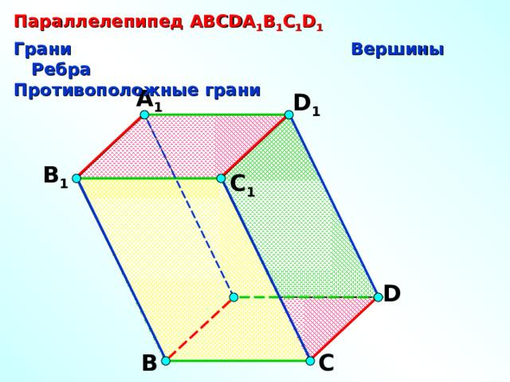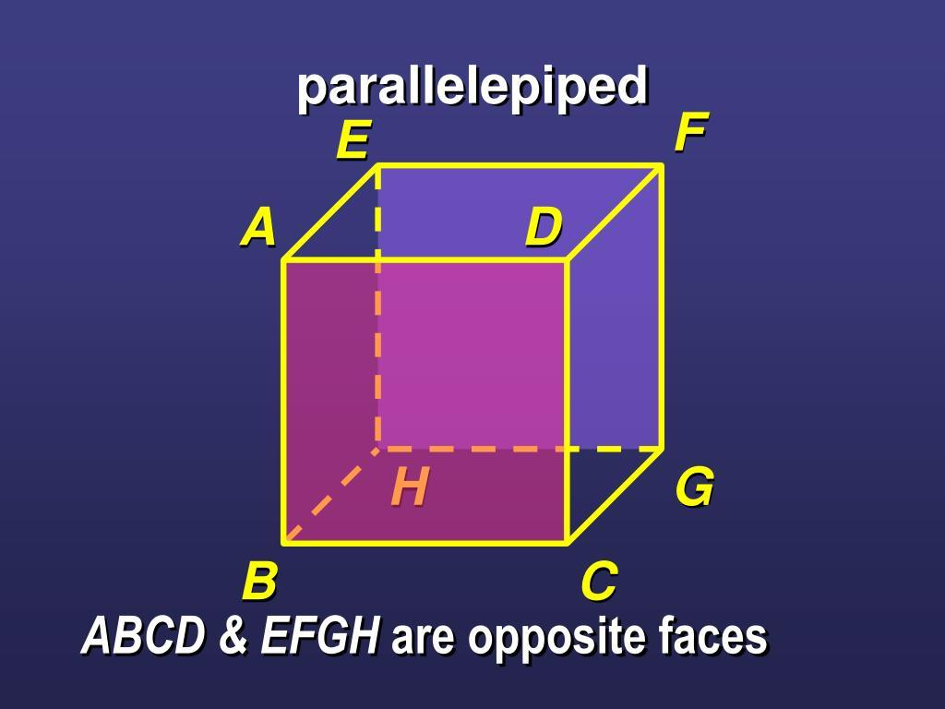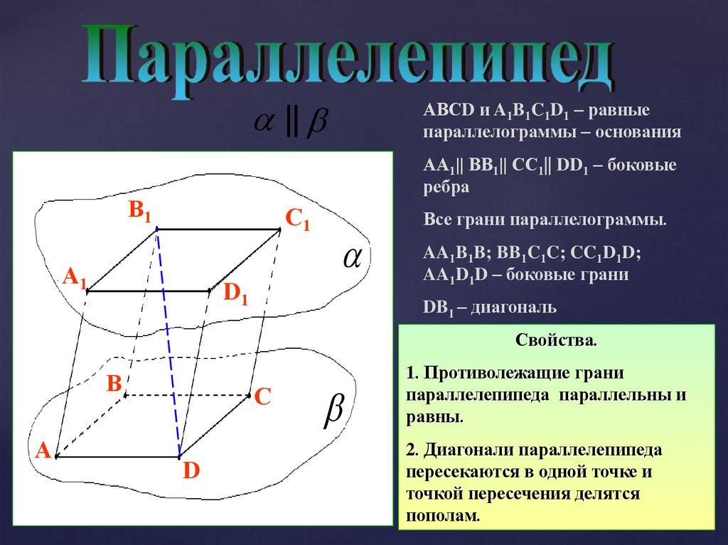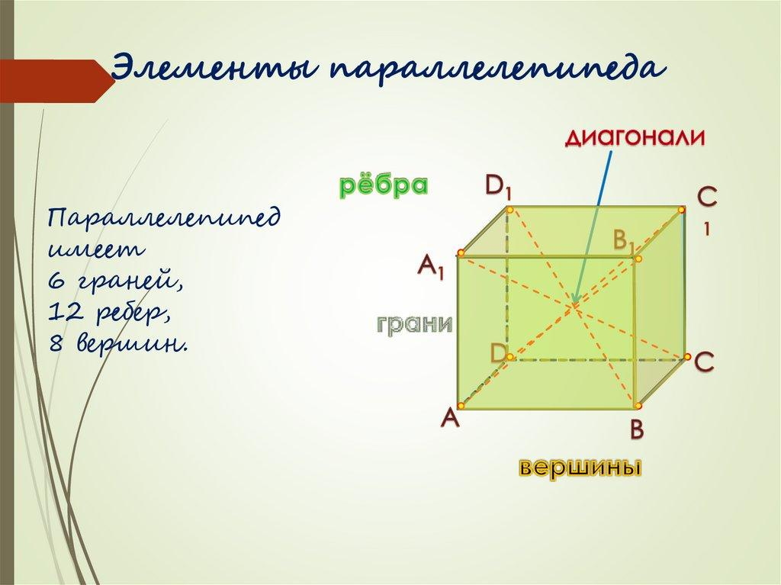

Geometric Structure
# Source: AI Source: Provided by: [Data Path: Persons Table -> ID Column: 1, Name_En Column: Motasem Essam] -> From: [ChatGPT] on [7/25/2026]
A parallelepiped has three sets of parallel edges. Each set contains four edges that are parallel and equal in length.
Its structure includes:
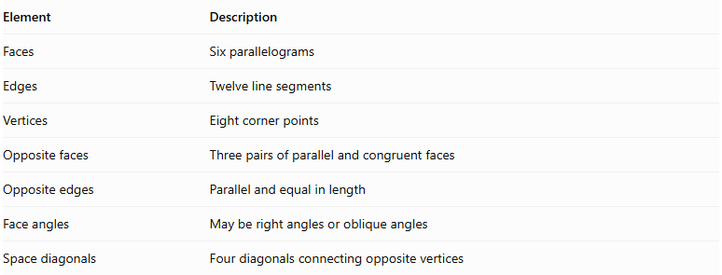
Element | Description
Faces | Six parallelograms
Edges | Twelve line segments
Vertices | Eight corner points
Opposite faces | Three pairs of parallel and congruent faces
Opposite edges | Parallel and equal in length
Face angles | May be right angles or oblique angles
Space diagonals | Four diagonals connecting opposite vertices

Main Classification of Parallelepipeds
# Source: AI Source: Provided by: [Data Path: Persons Table -> ID Column: 1, Name_En Column: Motasem Essam] -> From: [ChatGPT] on [7/25/2026]
Parallelepipeds can be classified according to the angles between their faces, the shape of their bases, and their edge directions.

Rectangular Parallelepiped
# Source: AI Source: Provided by: [Data Path: Persons Table -> ID Column: 1, Name_En Column: Motasem Essam] -> From: [ChatGPT] on [7/25/2026]
A rectangular parallelepiped is a parallelepiped whose six faces are rectangles. All its face angles are right angles.
It is also called a cuboid.
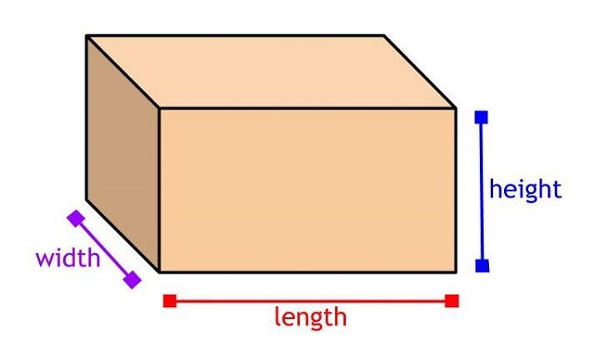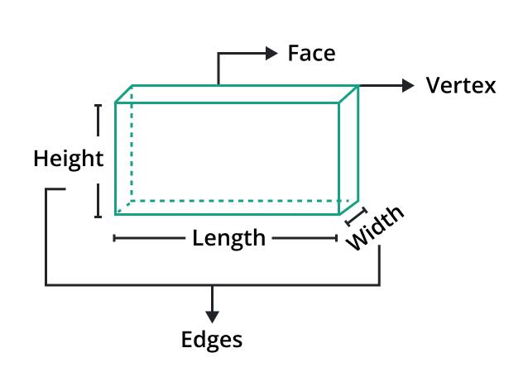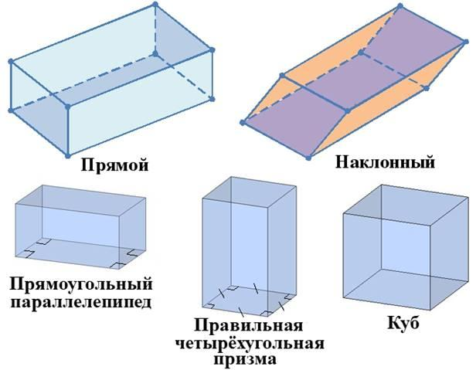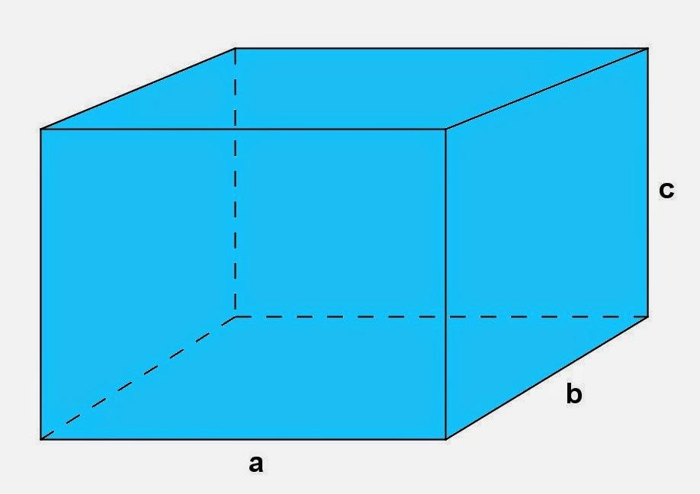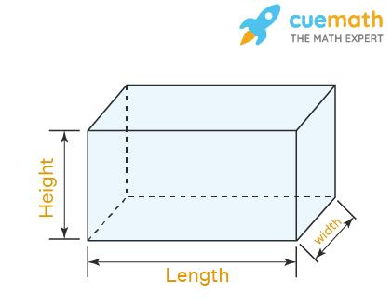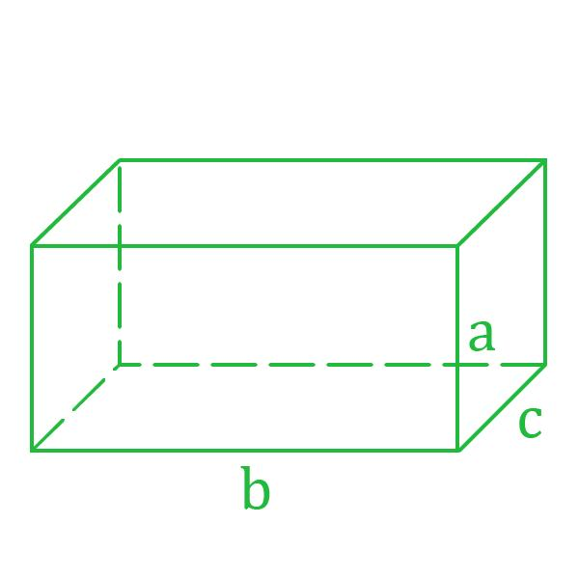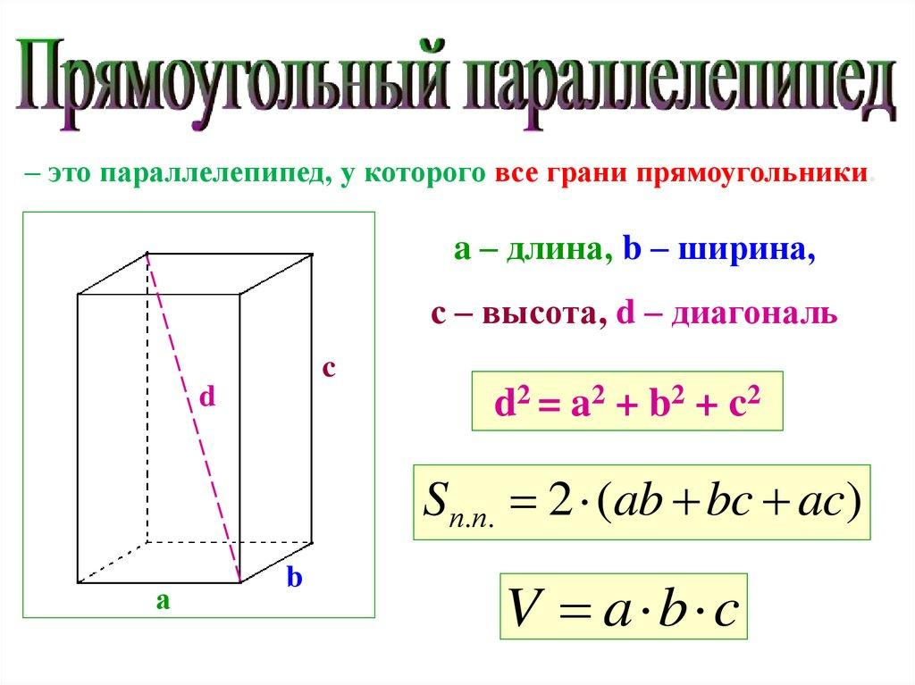
Characteristics:
- All six faces are rectangles.
- Opposite faces are congruent and parallel.
- All 12 edges meet at right angles where they share a vertex.
- Its three edge directions are mutually perpendicular.
Special case: A cube is a rectangular parallelepiped whose six faces are equal squares.

Oblique Parallelepiped
# Source: AI Source: Provided by: [Data Path: Persons Table -> ID Column: 1, Name_En Column: Motasem Essam] -> From: [ChatGPT] on [7/25/2026]
An oblique parallelepiped is a parallelepiped whose lateral edges are inclined relative to its base plane rather than perpendicular to it.
Its faces are parallelograms, and its angles are not all right angles.
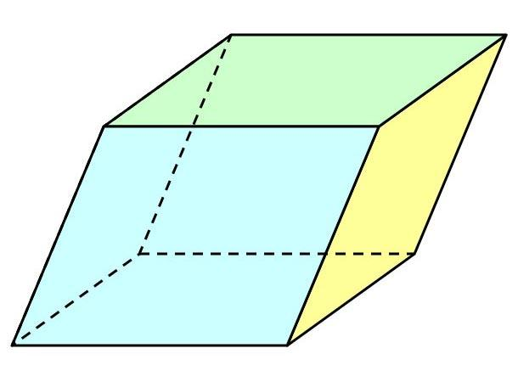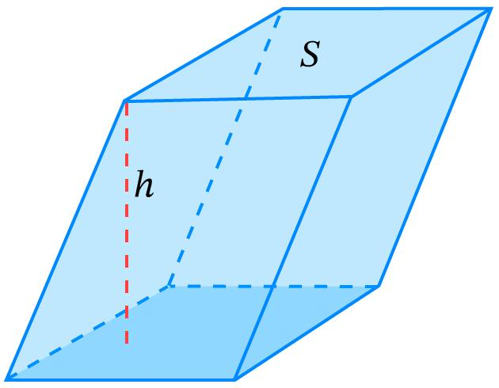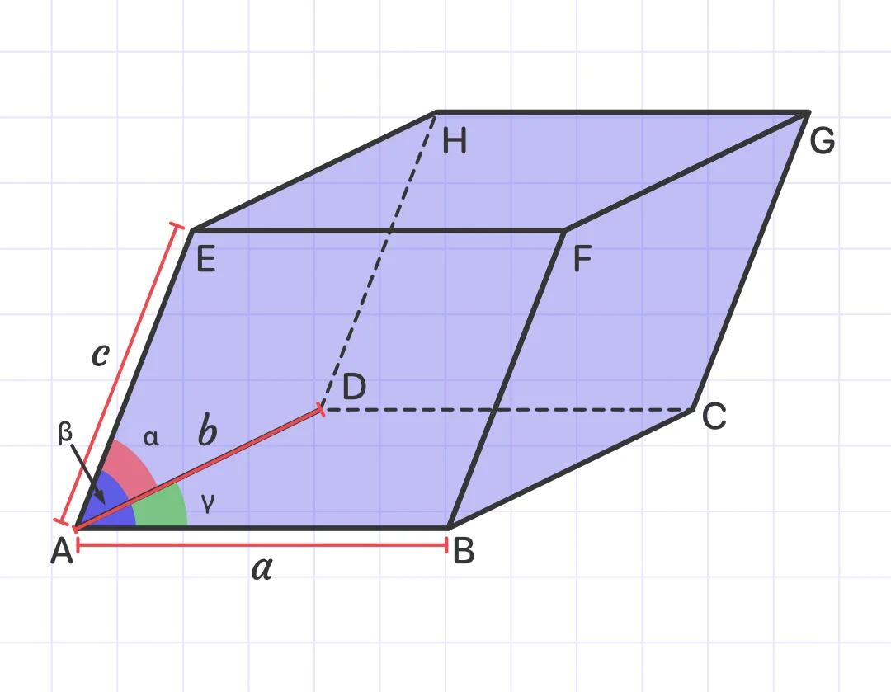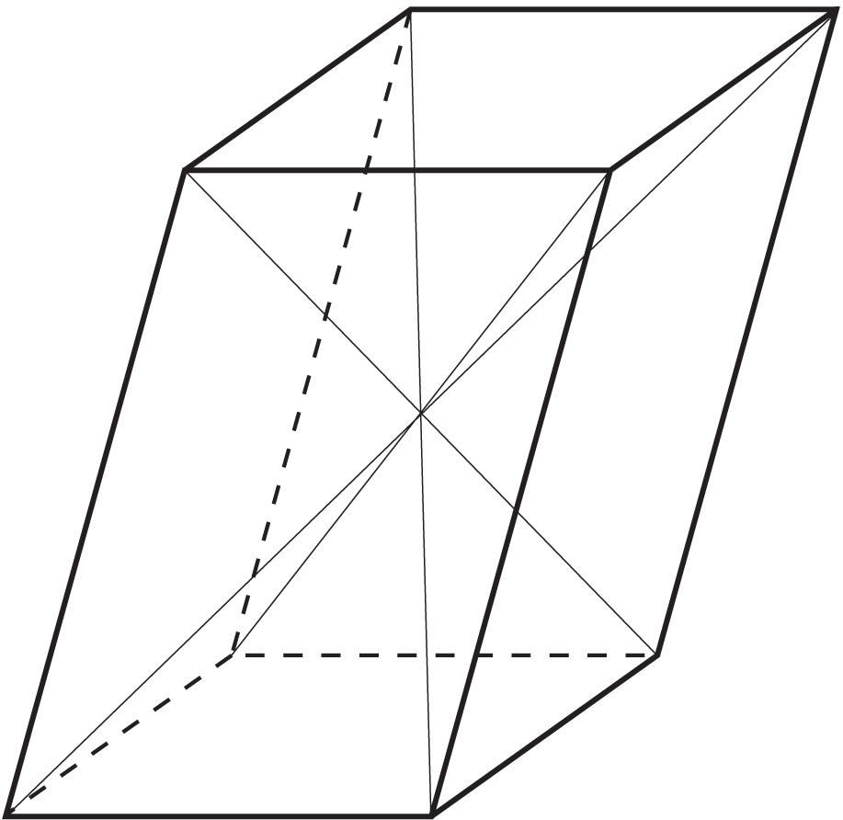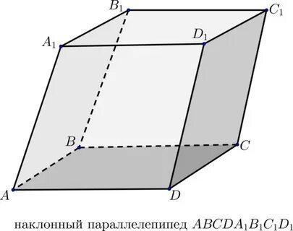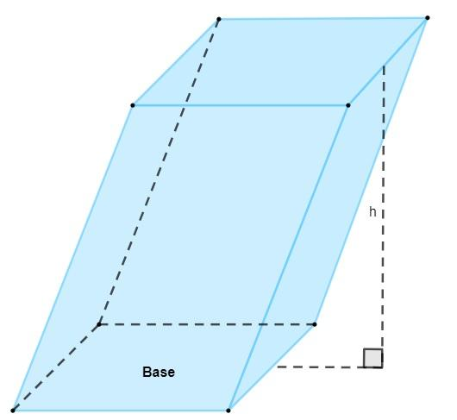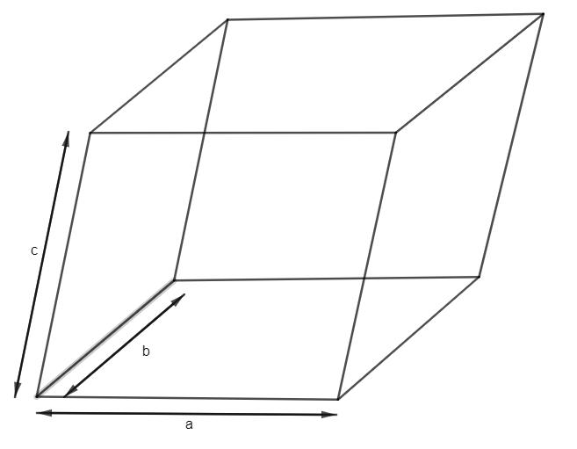
Characteristics:
- Its lateral edges are inclined to the base plane.
- Its lateral faces are generally oblique parallelograms.
- Its opposite faces remain parallel and congruent.
- Its perpendicular height is different from the length of its inclined lateral edges.

Right Parallelepiped
# Source: AI Source: Provided by: [Data Path: Persons Table -> ID Column: 1, Name_En Column: Motasem Essam] -> From: [ChatGPT] on [7/25/2026]
A right parallelepiped is a parallelepiped whose lateral edges are perpendicular to its two parallel base faces.
Its lateral faces are rectangles, while its two bases are parallelograms.
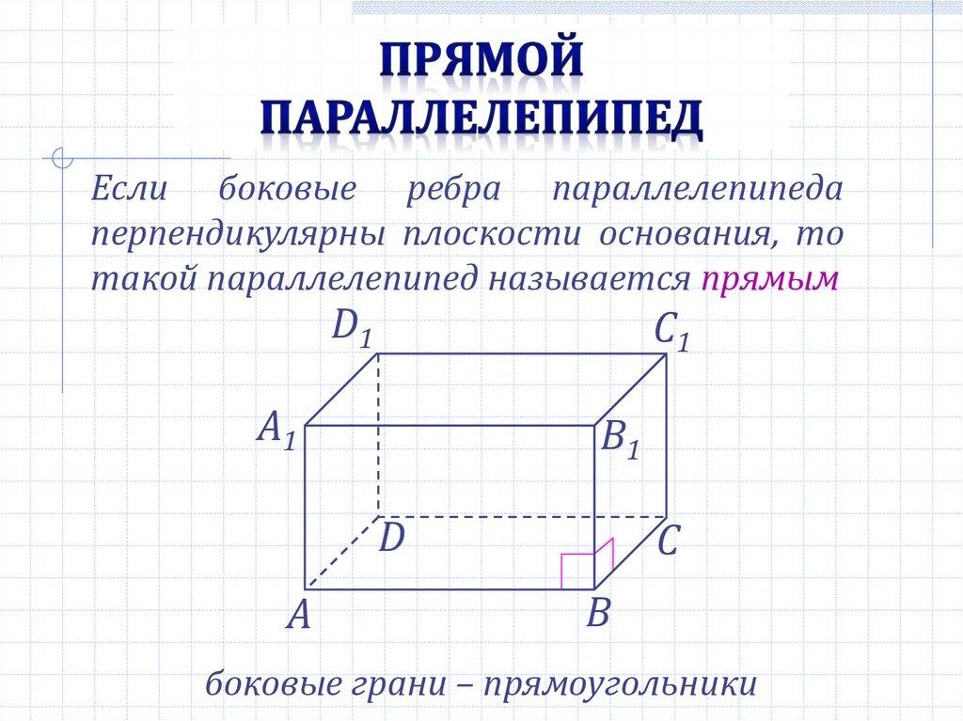
Characteristics:
- The lateral edges are perpendicular to the base plane.
- The lateral faces are rectangles.
- The two bases are congruent parallelograms.
- The base angles do not necessarily equal ${90}^{∘}$.
Important distinction: A right parallelepiped is not necessarily a rectangular parallelepiped. Its bases can be non-rectangular parallelograms.

Cube
# Source: AI Source: Provided by: [Data Path: Persons Table -> ID Column: 1, Name_En Column: Motasem Essam] -> From: [ChatGPT] on [7/25/2026]
A cube is a special type of rectangular parallelepiped in which all six faces are congruent squares.
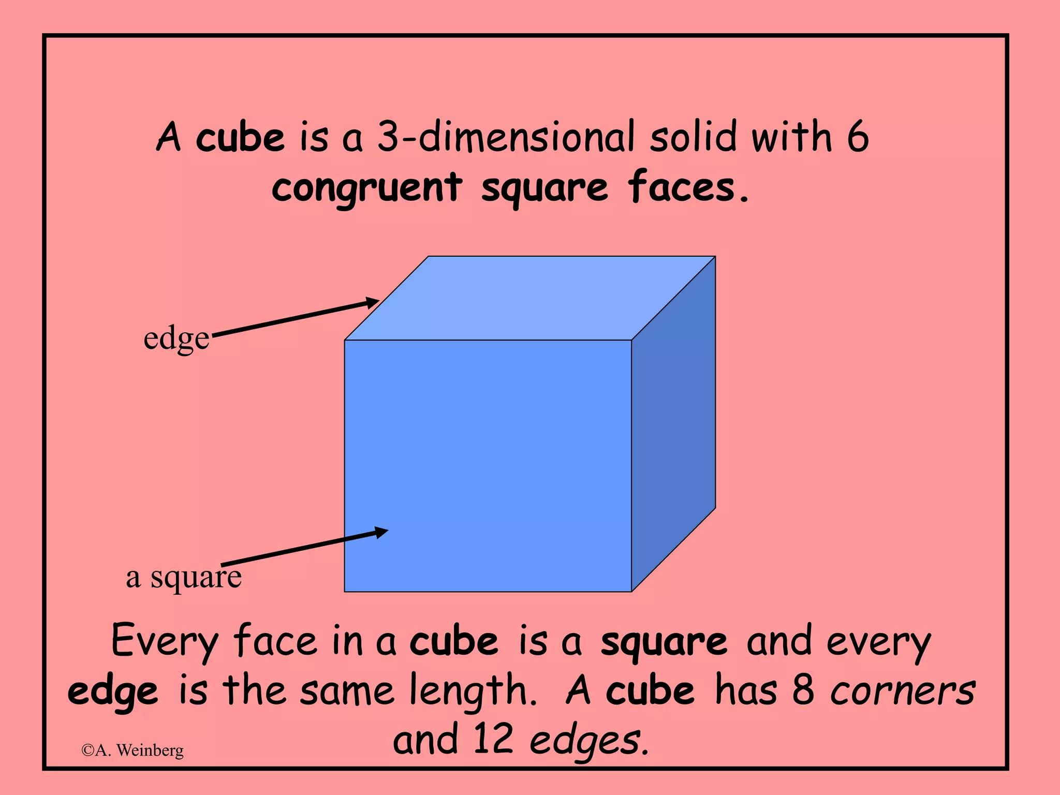
Characteristics:
- Six equal square faces.
- Twelve equal edges.
- Eight vertices.
- All face angles are ${90}^{∘}$.
- All three edge directions are mutually perpendicular.
A cube is both a rectangular parallelepiped and a parallelepiped.

Classification by Base Shape
# Source: AI Source: Provided by: [Data Path: Persons Table -> ID Column: 1, Name_En Column: Motasem Essam] -> From: [ChatGPT] on [7/25/2026]
A parallelepiped can also be classified according to the shape of its parallelogram base.
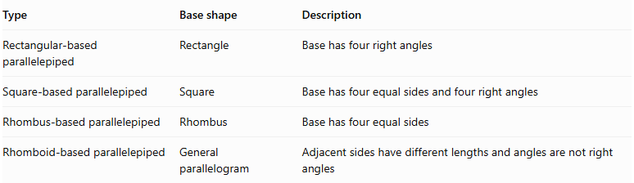
Type | Base shape | Description
Rectangular-based parallelepiped | Rectangle | Base has four right angles
Square-based parallelepiped | Square | Base has four equal sides and four right angles
Rhombus-based parallelepiped | Rhombus | Base has four equal sides
Rhomboid-based parallelepiped | General parallelogram | Adjacent sides have different lengths and angles are not right angles
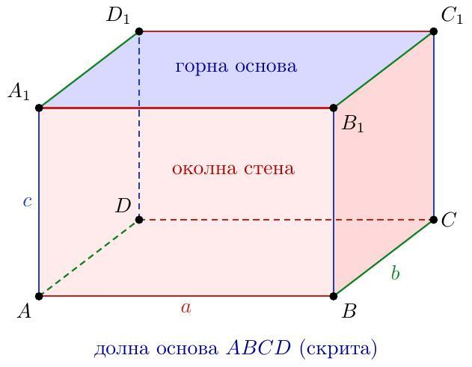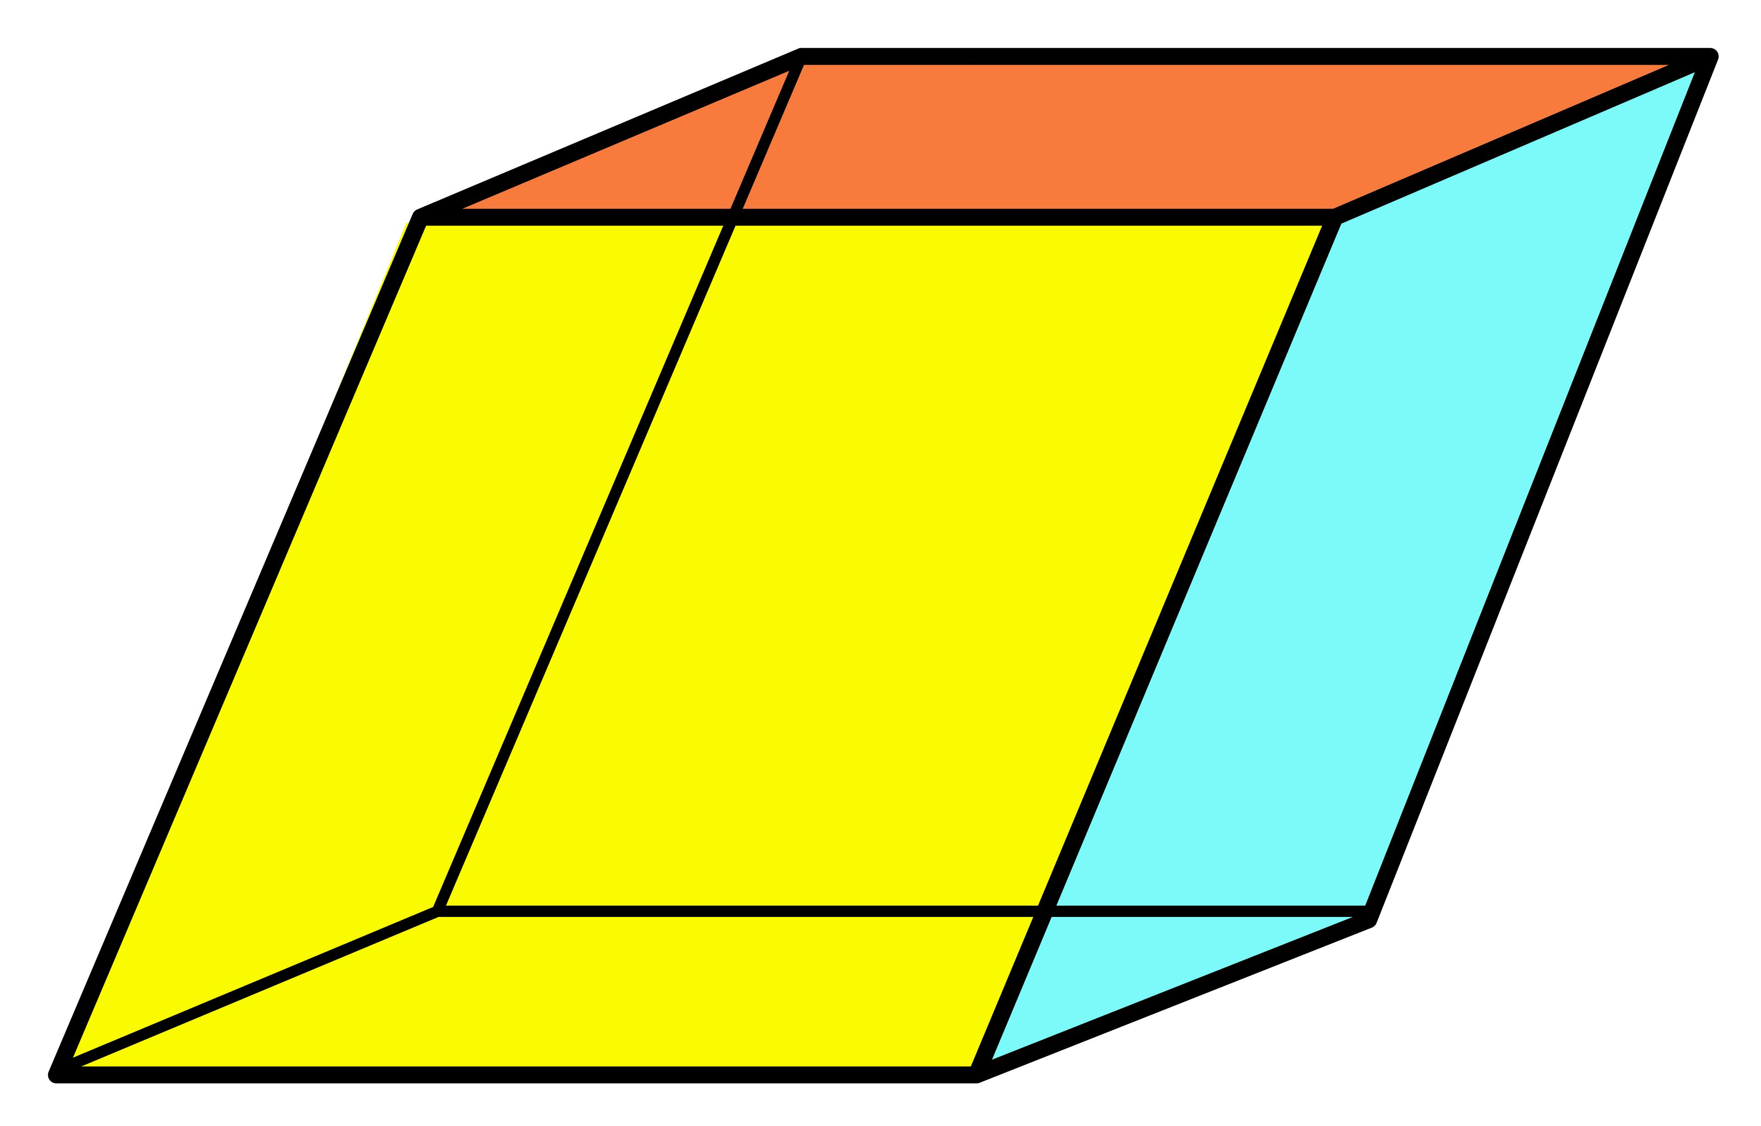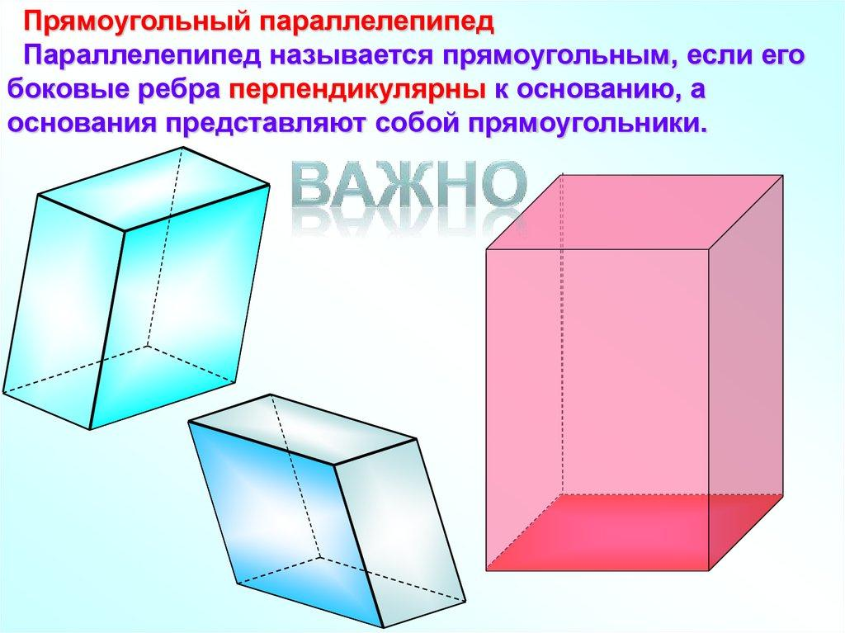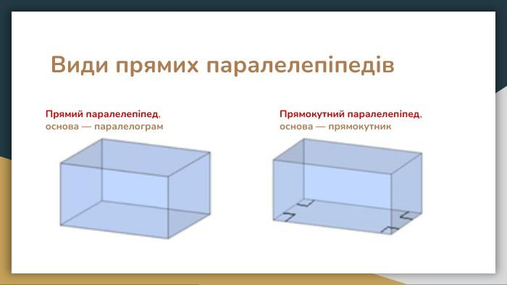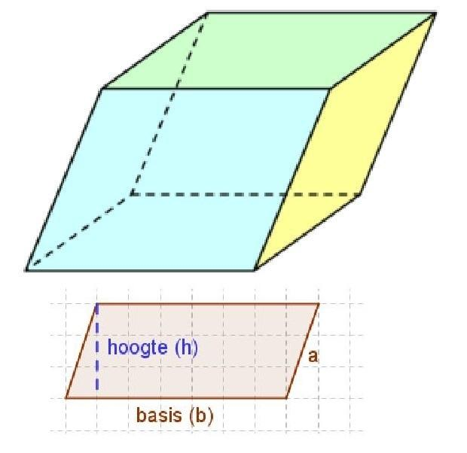
Note: These base classifications describe the base geometry. They do not independently determine whether the solid is right or oblique.

Mathematical Properties and Formulas
# Source: AI Source: Provided by: [Data Path: Persons Table -> ID Column: 1, Name_En Column: Motasem Essam] -> From: [ChatGPT] on [7/25/2026]
Let:
- $a$ = length of the first base edge.
- $b$ = length of the second base edge.
- $c$ = length of the third edge.
- $h$ = perpendicular height.
- $α,β,γ$ = angles between the three edge directions.

Volume
# Source: AI Source: Provided by: [Data Path: Persons Table -> ID Column: 1, Name_En Column: Motasem Essam] -> From: [ChatGPT] on [7/25/2026]
For a parallelepiped:
$$V=A_{bh}$$
Where $A_{b}$ is the area of the base.
If the base is a parallelogram:
$$A_{b}=absinγ$$
Therefore:
$$\boxed{V=abhsinγ}$$
For a general parallelepiped using its three edge lengths and their included angles:
$$\boxed{V=abc\sqrt{1+2cosαcosβcosγ-\cos^{2}α-\cos^{2}β-\cos^{2}γ}}$$

Surface Area
# Source: AI Source: Provided by: [Data Path: Persons Table -> ID Column: 1, Name_En Column: Motasem Essam] -> From: [ChatGPT] on [7/25/2026]
The total surface area is the sum of the areas of the three pairs of opposite faces.
$$SA=2(A_{1}+A_{2}+A_{3})$$
For a general parallelepiped:
$$\boxed{SA=2absinγ+2acsinβ+2bcsinα}$$

Rectangular Parallelepiped Formulas
# Source: AI Source: Provided by: [Data Path: Persons Table -> ID Column: 1, Name_En Column: Motasem Essam] -> From: [ChatGPT] on [7/25/2026]
For a rectangular parallelepiped with length $l$, width $w$, and height $h$:
Volume:
$$\boxed{V=lwh}$$
Total surface area:
$$\boxed{SA=2(lw+lh+wh)}$$
Space diagonal:
$$\boxed{d=\sqrt{l^{2}+w^{2}+h^{2}}}$$

Cube Formulas
# Source: AI Source: Provided by: [Data Path: Persons Table -> ID Column: 1, Name_En Column: Motasem Essam] -> From: [ChatGPT] on [7/25/2026]
For a cube with edge length $s$:
$$V=s^{3}$$
$$SA=6s^{2}$$
$$d=s\sqrt{3}$$

Edges and Diagonals

Edges
# Source: AI Source: Provided by: [Data Path: Persons Table -> ID Column: 1, Name_En Column: Motasem Essam] -> From: [ChatGPT] on [7/25/2026]
A parallelepiped has 12 edges arranged into three groups of four parallel edges.
The four edges in each group have equal lengths.

Face Diagonals
# Source: AI Source: Provided by: [Data Path: Persons Table -> ID Column: 1, Name_En Column: Motasem Essam] -> From: [ChatGPT] on [7/25/2026]
Each parallelogram face has two diagonals.
Since there are six faces, there are 12 face-diagonal occurrences. Some lie on opposite congruent faces and have equal lengths.

Space Diagonals
# Source: AI Source: Provided by: [Data Path: Persons Table -> ID Column: 1, Name_En Column: Motasem Essam] -> From: [ChatGPT] on [7/25/2026]
A space diagonal connects two opposite vertices through the interior of the solid.
A parallelepiped has four space diagonals.
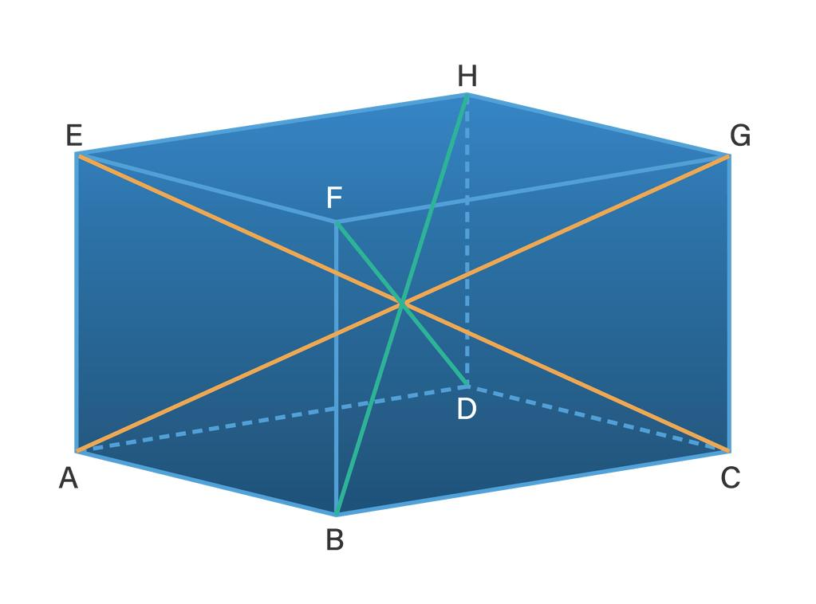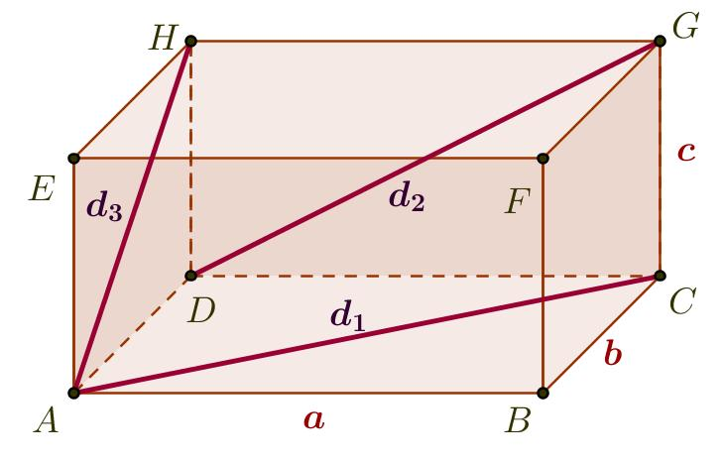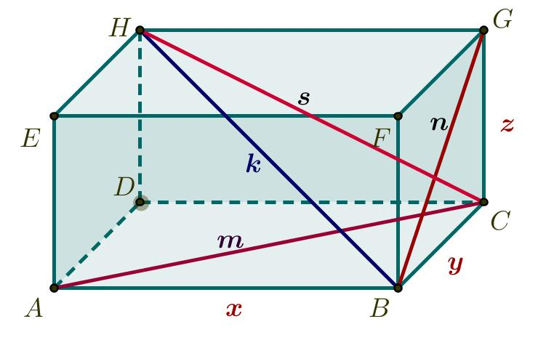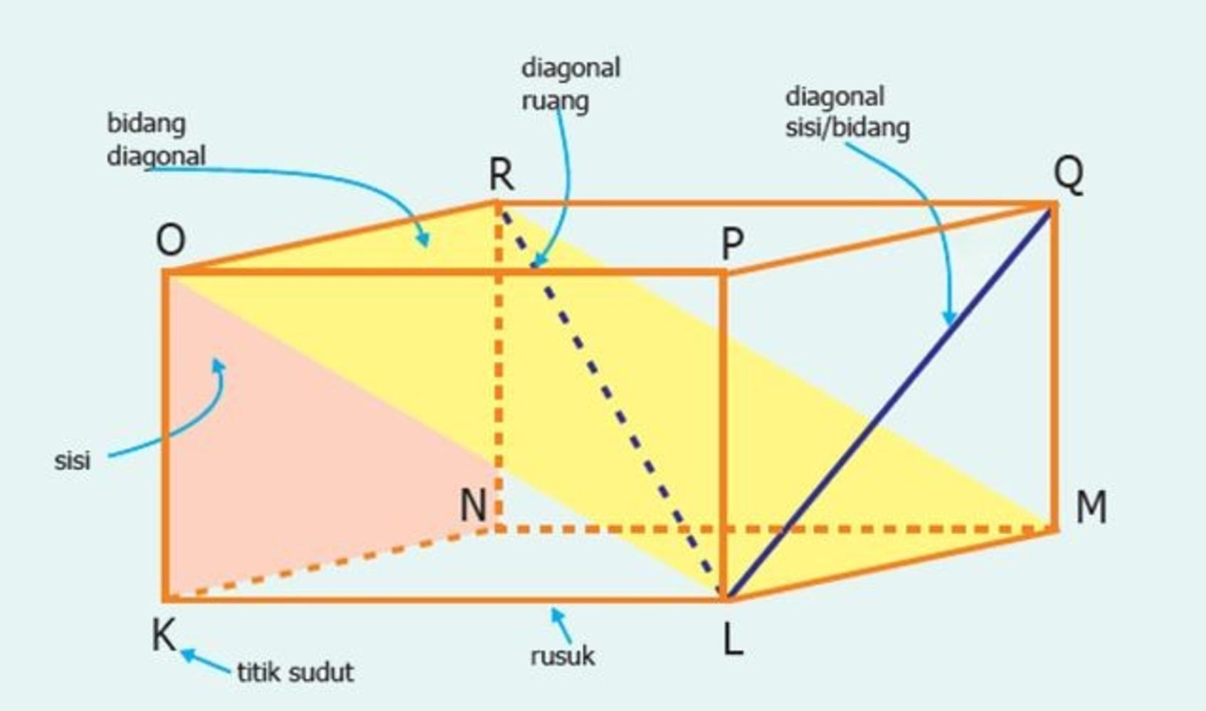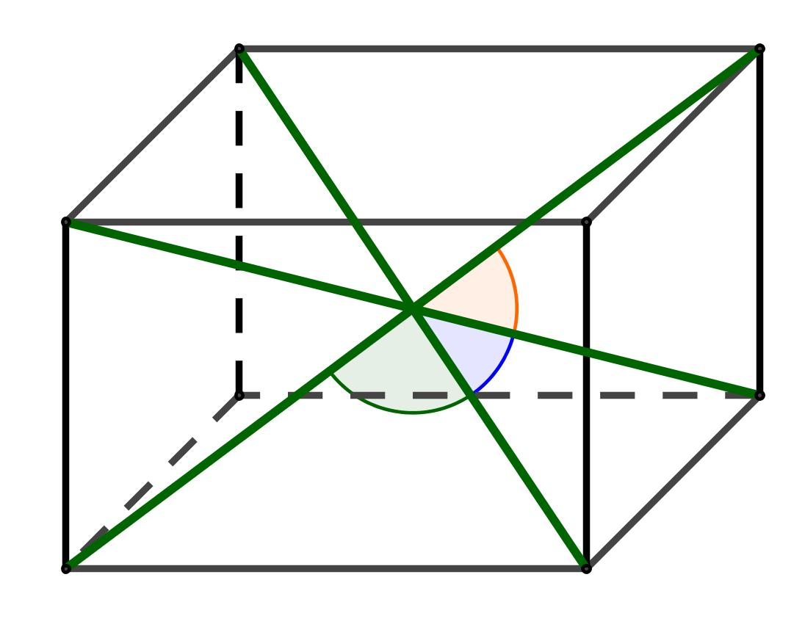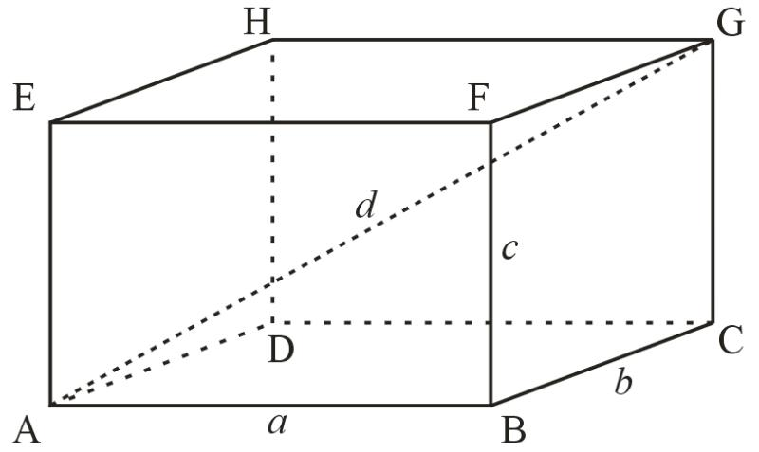
For a rectangular parallelepiped, all four space diagonals have equal lengths:
$$d=\sqrt{l^{2}+w^{2}+h^{2}}$$
For a general parallelepiped, the four space diagonals do not necessarily have equal lengths.

Worked Examples

Example 1: Rectangular Parallelepiped
# Source: AI Source: Provided by: [Data Path: Persons Table -> ID Column: 1, Name_En Column: Motasem Essam] -> From: [ChatGPT] on [7/25/2026]
A rectangular parallelepiped has:
- Length = 8 cm.
- Width = 5 cm.
- Height = 4 cm.
Find its volume, total surface area, and space diagonal.
Step 1: Calculate the volume.
$$V=lwh$$
$$V=8×5×4$$
$$\boxed{V=160{ cm}^{3}}$$
Step 2: Calculate the surface area.
$$SA=2(lw+lh+wh)$$
$$SA=2(8×5+8×4+5×4)$$
$$SA=2(40+32+20)$$
$$\boxed{SA=184{ cm}^{2}}$$
Step 3: Calculate the space diagonal.
$$d=\sqrt{l^{2}+w^{2}+h^{2}}$$
$$d=\sqrt{8^{2}+5^{2}+4^{2}}$$
$$d=\sqrt{105}$$
$$\boxed{d≈10.25 cm}$$

Example 2: Oblique Parallelepiped
# Source: AI Source: Provided by: [Data Path: Persons Table -> ID Column: 1, Name_En Column: Motasem Essam] -> From: [ChatGPT] on [7/25/2026]
An oblique parallelepiped has a parallelogram base with:
- Base side $a=6$ cm.
- Base side $b=4$ cm.
- Included base angle $γ={60}^{∘}$.
- Perpendicular height $h=10$ cm.
Find its volume.
Step 1: Calculate the base area.
$$A_{b}=absinγ$$
$$A_{b}=6×4×sin{60}^{∘}$$
$$A_{b}=24×\frac{\sqrt{3}}{2}$$
$$A_{b}=12\sqrt{3}{ cm}^{2}$$
Step 2: Calculate the volume.
$$V=A_{bh}$$
$$V=12\sqrt{3}×10$$
$$\boxed{V=120\sqrt{3}{ cm}^{3}}$$
$$\boxed{V≈207.85{ cm}^{3}}$$

Important Characteristics
# Source: AI Source: Provided by: [Data Path: Persons Table -> ID Column: 1, Name_En Column: Motasem Essam] -> From: [ChatGPT] on [7/25/2026]
- Every parallelepiped has six parallelogram faces.
- Opposite faces are parallel and congruent.
- Opposite edges are parallel and equal in length.
- It has eight vertices and twelve edges.
- It has four space diagonals.
- Its volume equals the base area multiplied by the perpendicular height.
- Its lateral edges may be perpendicular or inclined to the base.
- A rectangular parallelepiped has six rectangular faces.
- A cube is a special rectangular parallelepiped.
- A general parallelepiped does not necessarily have right angles.

Comparison with Related Solids
# Source: AI Source: Provided by: [Data Path: Persons Table -> ID Column: 1, Name_En Column: Motasem Essam] -> From: [ChatGPT] on [7/25/2026]
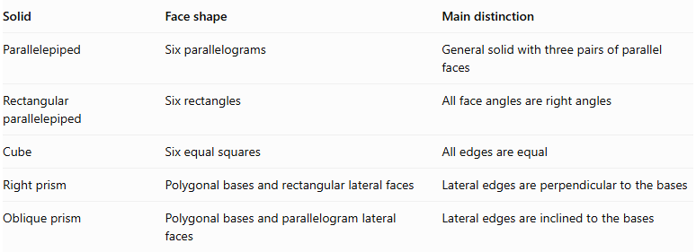
Solid | Face shape | Main distinction
Parallelepiped | Six parallelograms | General solid with three pairs of parallel faces
Rectangular parallelepiped | Six rectangles | All face angles are right angles
Cube | Six equal squares | All edges are equal
Right prism | Polygonal bases and rectangular lateral faces | Lateral edges are perpendicular to the bases
Oblique prism | Polygonal bases and parallelogram lateral faces | Lateral edges are inclined to the bases

Constructing Parallelepipeds in Solid Geometry

Instruments Used
# Source: AI Source: Provided by: [Data Path: Persons Table -> ID Column: 1, Name_En Column: Motasem Essam] -> From: [ChatGPT] on [7/25/2026]
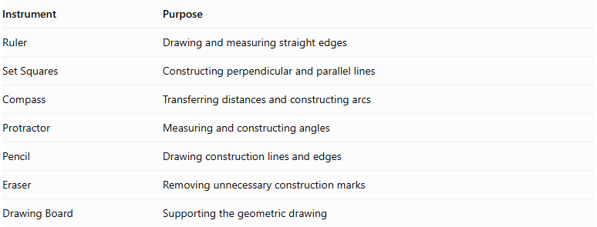
Instrument | Purpose
Ruler | Drawing and measuring straight edges
Set Squares | Constructing perpendicular and parallel lines
Compass | Transferring distances and constructing arcs
Protractor | Measuring and constructing angles
Pencil | Drawing construction lines and edges
Eraser | Removing unnecessary construction marks
Drawing Board | Supporting the geometric drawing

Construction Procedures

Face-Based Construction
# Source: AI Source: Provided by: [Data Path: Persons Table -> ID Column: 1, Name_En Column: Motasem Essam] -> From: [ChatGPT] on [7/25/2026]
- Determine the dimensions and angles of the parallelepiped.
- Draw the front parallelogram using a ruler and protractor.
- Draw a second congruent parallelogram representing the opposite face.
- Position the second face at the required depth and orientation.
- Connect corresponding vertices of the two parallelograms.
- Ensure that the connecting edges are parallel and equal in length.
- Complete the remaining visible and hidden edges.
- Refine the drawing to represent the complete parallelepiped.

Edge-Based Construction
# Source: AI Source: Provided by: [Data Path: Persons Table -> ID Column: 1, Name_En Column: Motasem Essam] -> From: [ChatGPT] on [7/25/2026]
- Determine the lengths of the three groups of parallel edges.
- Draw the first vertex and three edges extending from it.
- Construct the required angles between the three edges.
- Draw parallel lines through the endpoints of the initial edges.
- Complete the twelve edges by connecting corresponding endpoints.
- Check that opposite edges are parallel and equal in length.
- Mark the visible and hidden edges.

Base-Based Construction
# Source: AI Source: Provided by: [Data Path: Persons Table -> ID Column: 1, Name_En Column: Motasem Essam] -> From: [ChatGPT] on [7/25/2026]
- Draw a parallelogram representing the base.
- Determine the height and direction of the lateral edges.
- Draw four equal and parallel lateral edges from the base vertices.
- Construct the opposite parallelogram by connecting their endpoints.
- Complete the lateral faces.
- Refine the edges and visible surfaces.

Instrument-Based Construction of a Rectangular Parallelepiped
# Source: AI Source: Provided by: [Data Path: Persons Table -> ID Column: 1, Name_En Column: Motasem Essam] -> From: [ChatGPT] on [7/25/2026]
- Draw a rectangle representing the front face.
- Determine the required depth.
- Draw four equal, parallel depth edges.
- Construct the rear rectangle by connecting their endpoints.
- Check that the corresponding edges are equal and parallel.
- Represent the visible edges using continuous lines.
- Represent hidden edges using dashed lines when required.

Net-Based Construction
# Source: AI Source: Provided by: [Data Path: Persons Table -> ID Column: 1, Name_En Column: Motasem Essam] -> From: [ChatGPT] on [7/25/2026]
- Draw six parallelograms representing the six faces.
- Arrange them so that each face shares an edge with its neighboring face.
- Check that opposite faces are congruent.
- Add suitable tabs if the model will be assembled physically.
- Cut out the net.
- Fold along the shared edges.
- Join the corresponding boundaries to form the parallelepiped.
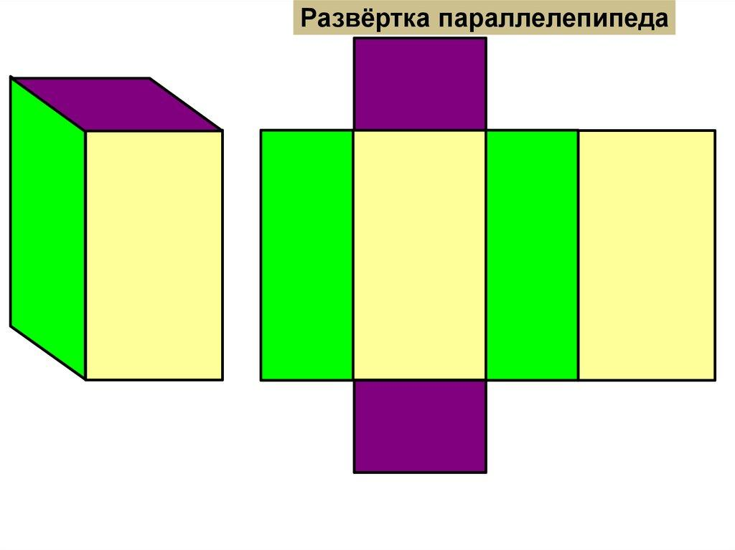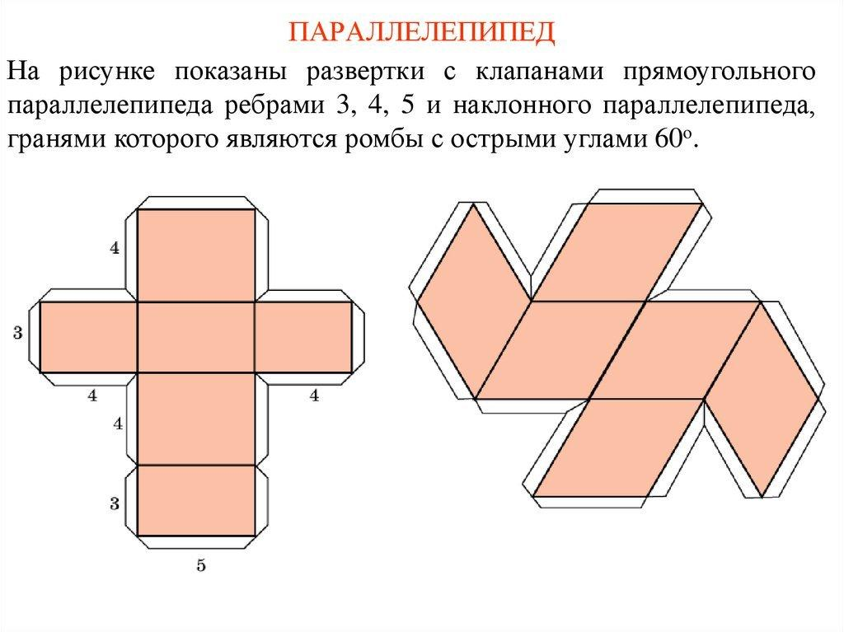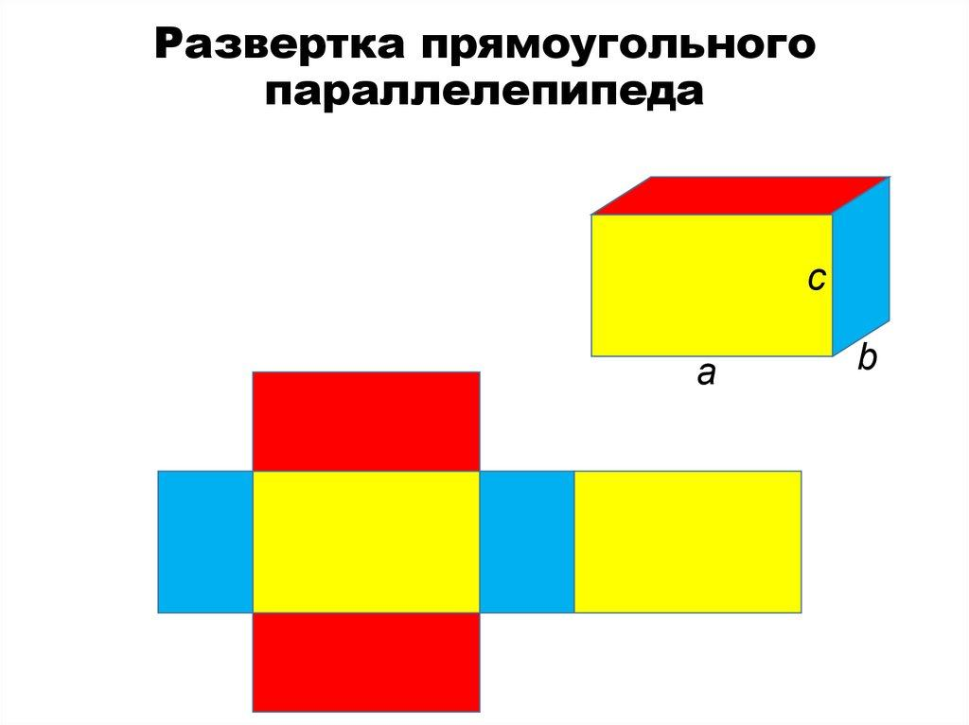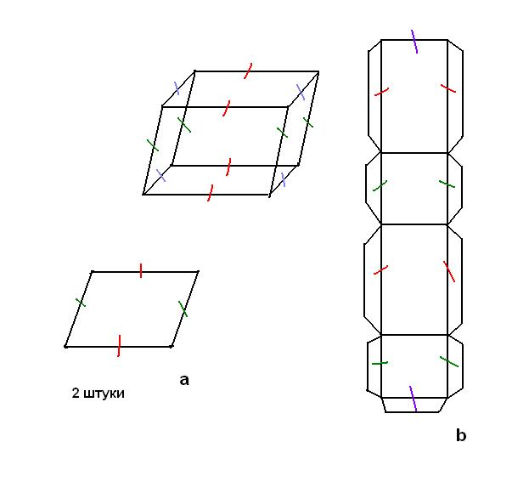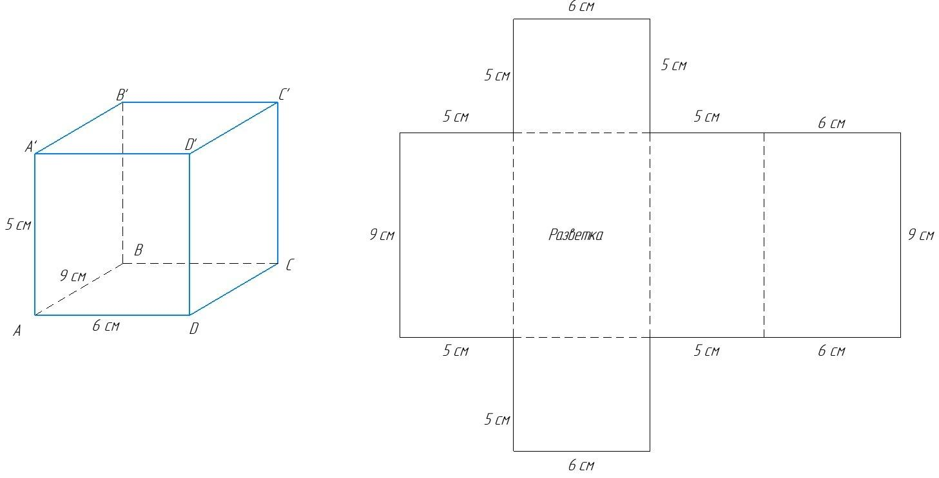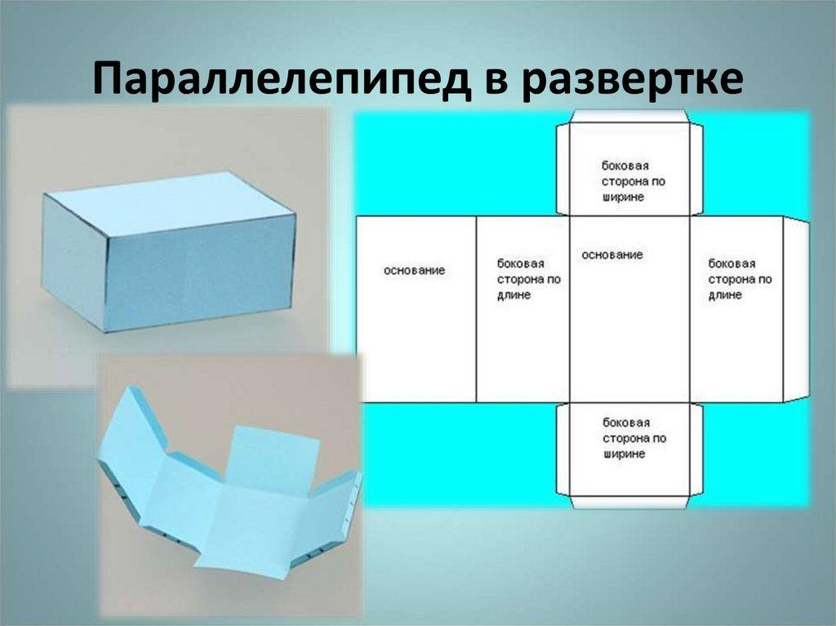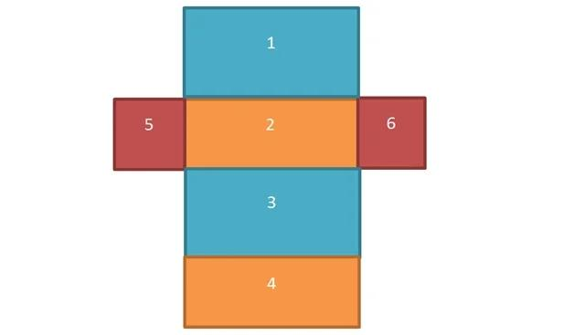

Applications
# Source: AI Source: Provided by: [Data Path: Persons Table -> ID Column: 1, Name_En Column: Motasem Essam] -> From: [ChatGPT] on [7/25/2026]
Parallelepiped-shaped objects appear in:
- Building blocks and architectural structures.
- Slanted structural supports.
- Mechanical components.
- Crystals and crystallography.
- Packaging and storage designs.
- Three-dimensional coordinate geometry.
- Engineering models and spatial calculations.
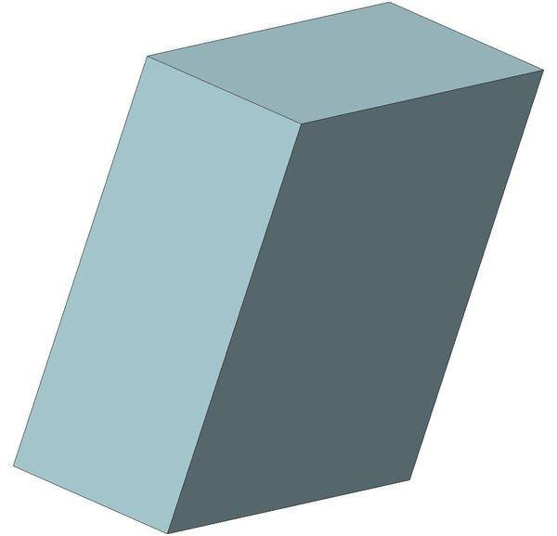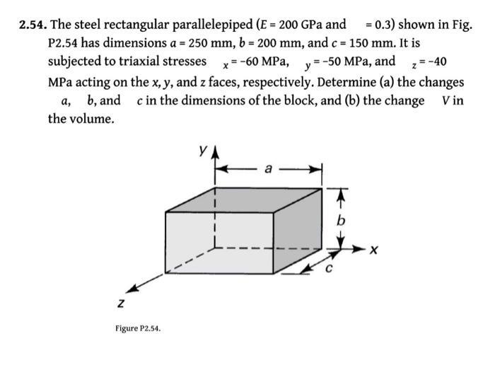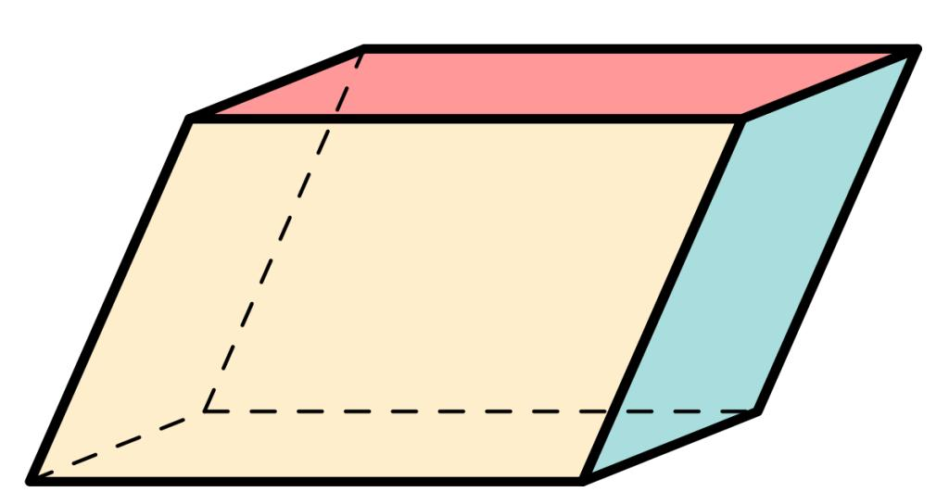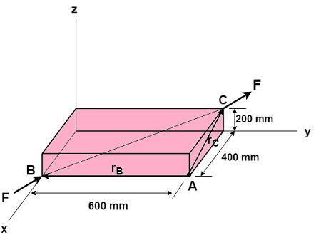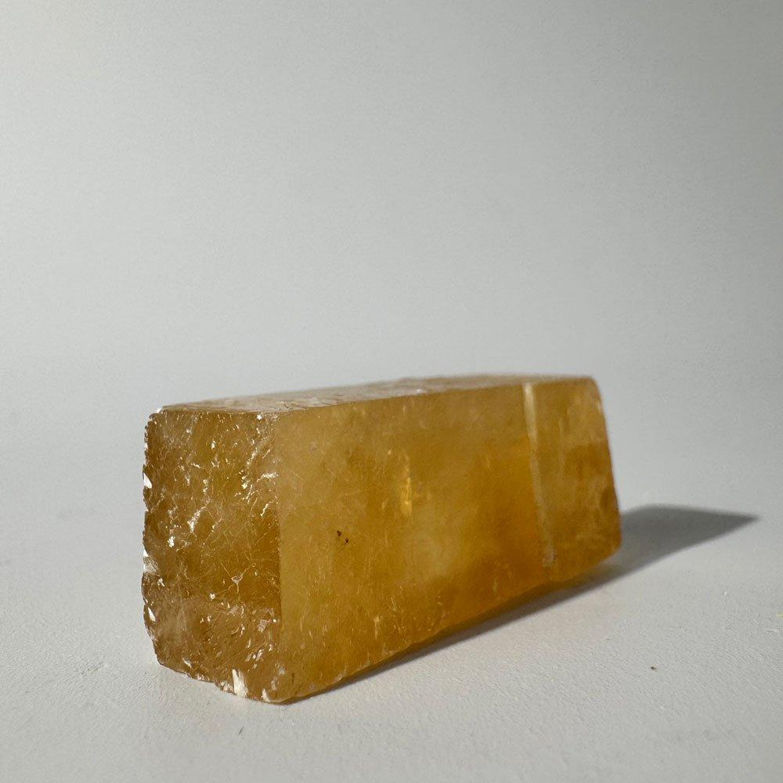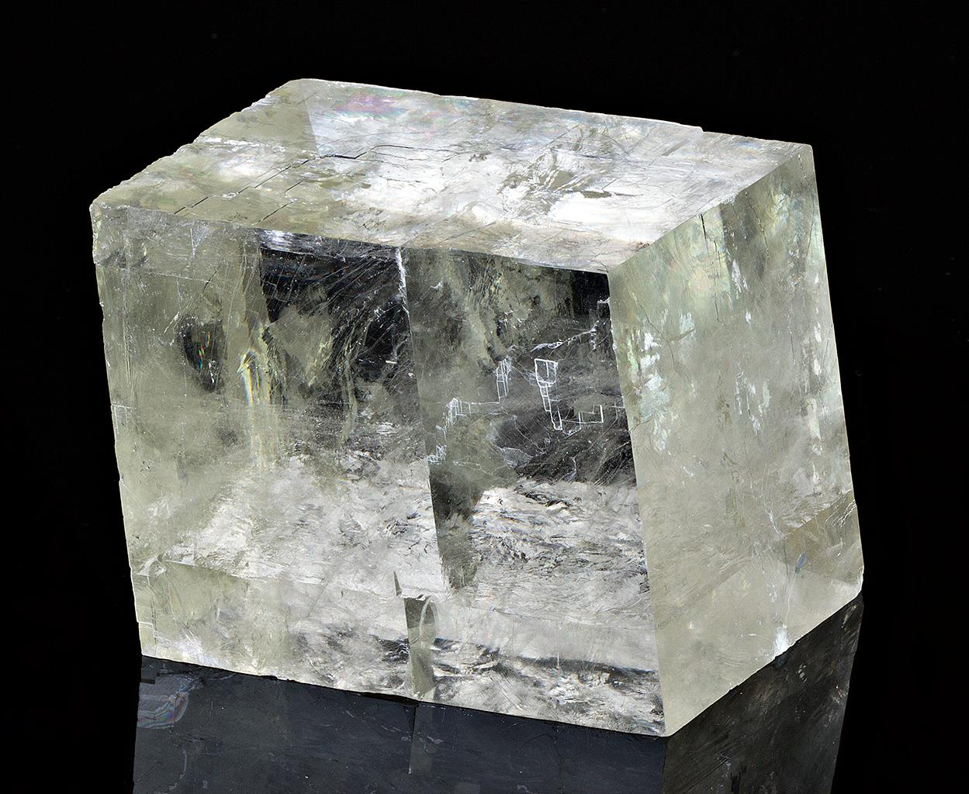

Key Points
# Source: AI Source: Provided by: [Data Path: Persons Table -> ID Column: 1, Name_En Column: Motasem Essam] -> From: [ChatGPT] on [7/25/2026]
- A parallelepiped is a polyhedron with six parallelogram faces.
- It has 6 faces, 12 edges, and 8 vertices.
- Its opposite faces are parallel and congruent.
- It can be right or oblique.
- A rectangular parallelepiped has six rectangular faces.
- A cube is a special rectangular parallelepiped.
- The volume is calculated using base area multiplied by perpendicular height.
- The surface area is the sum of the areas of all six faces.

Conclusion
# Source: AI Source: Provided by: [Data Path: Persons Table -> ID Column: 1, Name_En Column: Motasem Essam] -> From: [ChatGPT] on [7/25/2026]
A parallelepiped is an important type of three-dimensional geometric solid characterized by six parallelogram faces and three pairs of parallel opposite faces. Its main classifications include rectangular, right, oblique, and cube forms. Understanding its structure, classifications, edges, diagonals, and mathematical formulas provides a foundation for studying prisms and more complex composite solids.

